**1. Being able to solve a linear system (making use of the EF form of the associated** **2**

1.2 Understand the possible solutions 2

**2. Reduce a matrix to EF form, find the pivot positions** **2**

**3. Solve a homogeneous linear system (Ax=0) and find the solution set in parametric vector form** **3**

**4. Solve a linear system in the form A x = b (in matrix-vector form) and find the solution set in parametric vector form (particular solution plus solutions of the homogeneous equation)** **4**

**5. Given a set of vectors, declare if they are linearly independent or not. If not, exhibit a linear dependence relation among them** **4**

**6. Basic matrix and vector operations (e.g. compute the product of two matrixes, ..)** **5**

**7. Find if a square matrix is invertible or not; if it is invertible, compute the inverse matrix** **6**

**8. Find the LU factorization (if available) of a matrix** **7**

8.1 Lower Triangular 8

8.2 Upper triangular 8

**9. Given a matrix A, find if a given vector is in Col(A), Nul(A)** **8**

**10. Given a matrix A, find a basis for Col(A), Nul(A)** **9**

**11. Given a set of vectors, declare if they are a basis and if a given vector is in the span** **10**

**12. Given a basis and a vector w, write the coordinates of w with respect to that basis** **10**

**13. Calculate the rank of a given matrix** **10**

**14. Calculate the determinant of a given square matrix using the standard formula** **11**

14.1 Determinant of a 2x2 square matrix 11

14.2 Determine of a 3x3 square matrix 11

**15. Calculate the determinant of a given square matrix using the LU approach** **12**

**16. Find the (real) eigenvalues of a matrix** **12**

**17. Given an eigenvalue of a matrix, calculate a basis of the associated eigenspace** **13**

**18. Combine the two above (find all the eigenvalues and associated eigenspaces of a matrix)** **14**

**19. Tell if a matrix is diagonalizable, and (if yes) compute the P and D matrixes** **14**

**!!! 20. Compute scalar products of vectors, norms, orthogonal projections** **15**

**21. Given a set of linearly independent vectors spanning H, compute an orthonormal basis for H (by using the Gram-Schmidt procedure)** **16**

**22. Given a matrix A with linearly independent columns, compute its QR factorization** **17**

**23. Find the solution of a least squares problem using the normal equations** **18**

**24. Find the solution of a least squares problem using the QR factorization** **19**

**25. Given a matrix A, answer if the associated least squares problem has a unique solution** **20**

# 1. Being able to solve a linear system (making use of the EF form of the associated

Use elementary row operations

1. Exchange two rows
2. Multiply any row by α € IR, α ≠ 0
3. Subtract and row multiply by α € IR to any other row

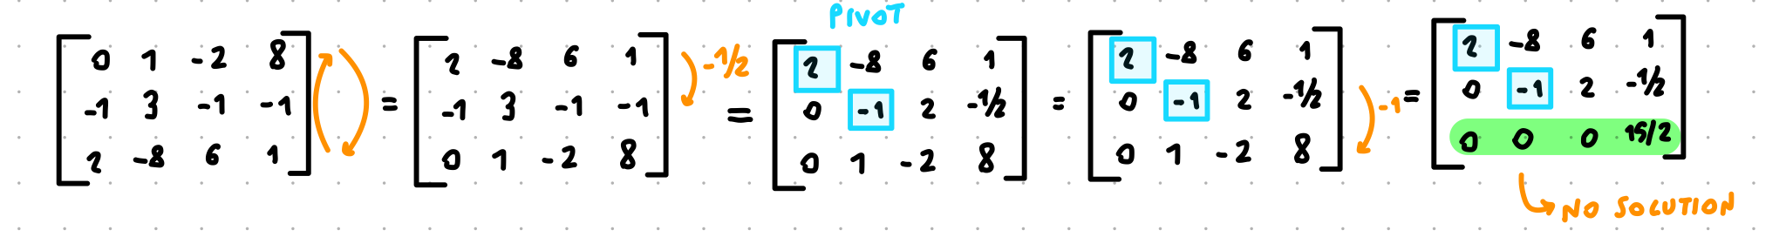

## 1.2 Understand the possible solutions

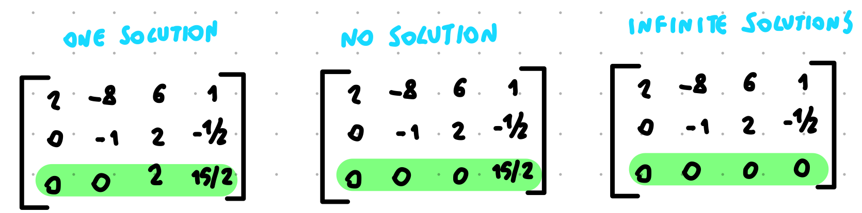

# 2. Reduce a matrix to EF form, find the pivot positions

Use the elementary row operation to have a matrix in the form:

- All rows full of zeros ar at the bottom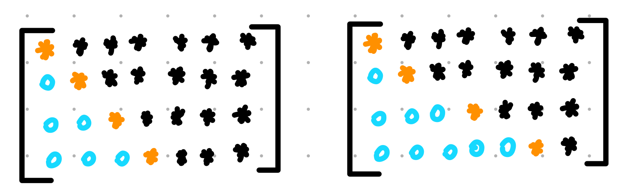

- The leading entry (leftmost non-zero entry) is on the right of the leading entry of the rows above

* general number

0 zero

* different from zero

Things to know:

* Any matrix can be transformed in echelon form (EF) by the row reduction algorithm (sequence of elementary row operation)
* Any matrix is row equivalent to a matrix in EF, such EF matrix is not unique
* Even if there are multiple EF matrix for the same matrix, the position of the leading entry of all the rows of the EF matrixes are the same

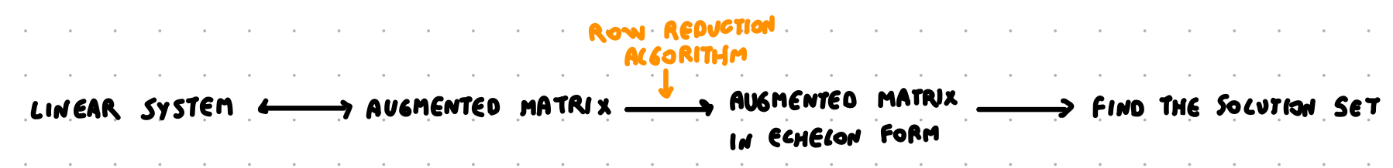

# 3. Solve a homogeneous linear system (Ax=0) and find the solution set in parametric vector form

* A system of linear equation is homogeneous if it can be written as Ax = 0
* An homogeneous linear system has always the trivial solution (vector 0)
* An homogeneous linear system has a non-trivial solution if there is at least one free variable

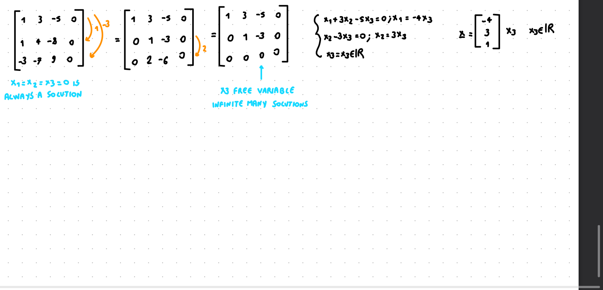

# 4. Solve a linear system in the form A x = b (in matrix-vector form) and find the solution set in parametric vector form (particular solution plus solutions of the homogeneous equation)

Given A € IRm x n and b € IRm search for x € IRn that satisfy Ax = b

Things to know:

* The linear system will have at least ( = or one or infinite) solutions of x

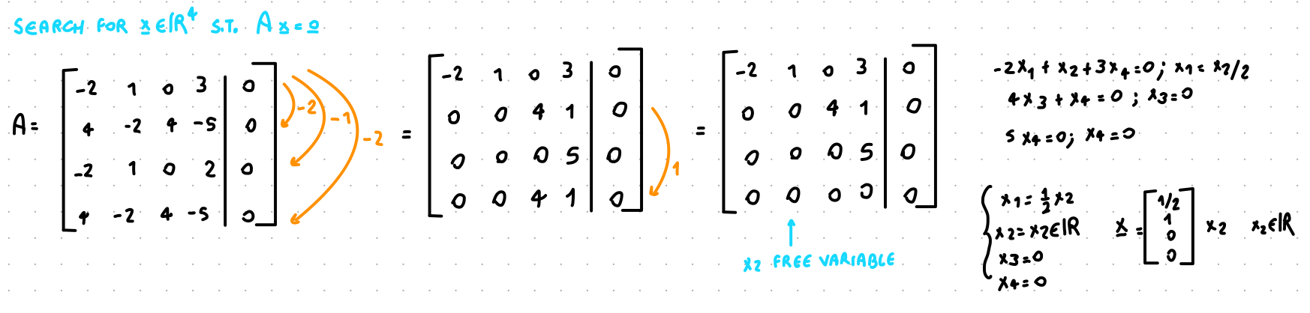

# 5. Given a set of vectors, declare if they are linearly independent or not. If not, exhibit a linear dependence relation among them

Linearly independent: only one solution (all 0)

Linearly dependent: there exists at least one solution that is ≠ 0

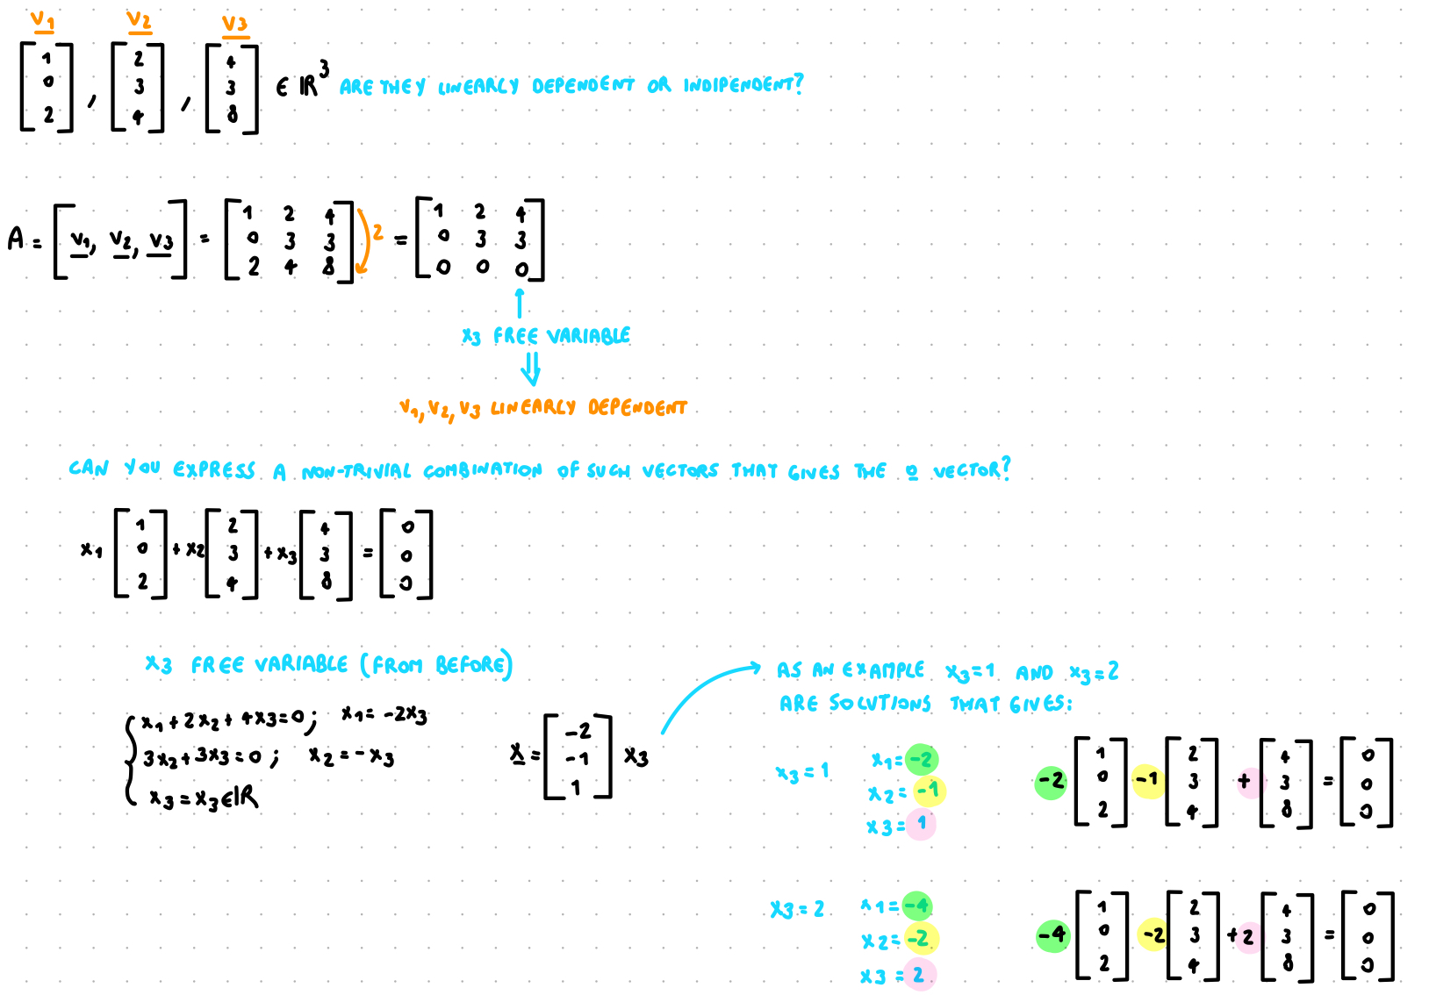

Things to know:

* Free variable ⟹ infinite solutions ⟹ linearly dependent
* No free variable ⟹ one solution (0 vector) ⟹ linearly independent
* Given {v1, v2, v3, … , vp } € IRn if **p > n** they must be linearly dependent
* Given {v1, v2, v3, … , vp } € IRn if one of the vector is equal to 0 the vectors are linearly dependent

# 6. Basic matrix and vector operations (e.g. compute the product of two matrixes, ..)

Product of a matrix and a vector

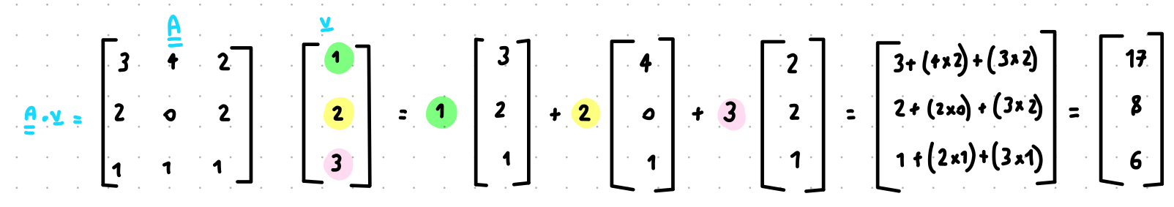

First of all check if you can multiply two matrices

if A € IRn x m and B € IRo x p you can do AB only if *m=o* that is only if the number of columns of the first matrix is the same as the number of rows of the second matrix. Furthermore the result matrix will be a matrix € IRn x p

AB ≠ BA

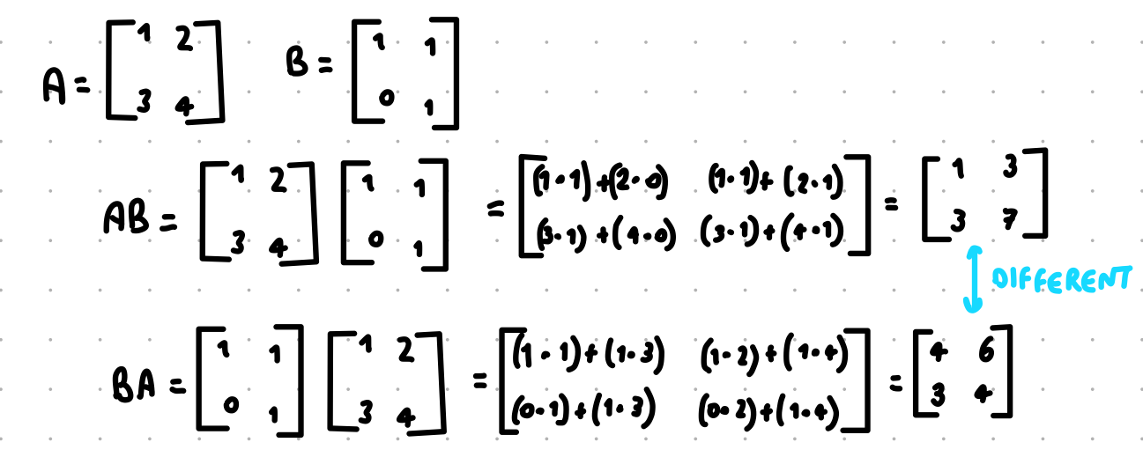

Things to know:

* AB ≠ BA
* If AB = AC ⇏ B = C
* If AB =0 (0 is a matrix) ⇏ A=0 or B=0
* A0 = In (only for square matrixes)

# 7. Find if a square matrix is invertible or not; if it is invertible, compute the inverse matrix

Given a square matrix A € IRn x n is invertible if it exist C € IRn x n such that CA = AC = In otherwise A is said non-invertibile

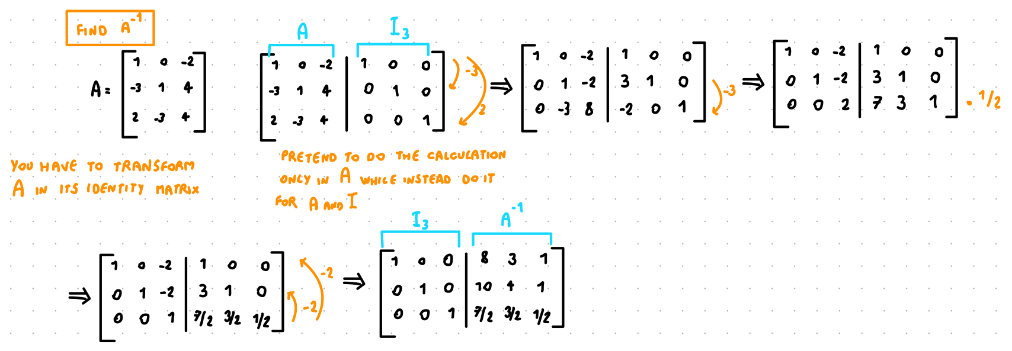

Things to know:

* A matrix to be invertible needs to be **squared** and needs to have a **pivot position for all the rows**
* If C exist it is unique and is the inverse of A, usually indicated with A-1

A € IRn x n (square) than the following statements are equivalent

* A is invertibile
* A is row-equivalent to In
* A has n pivot positions (all on the diagonal)
* The system Ax = 0 has only the trivial solution
* The equation Ax = b has (at least) one solution for each b€ IRn
* The columns of A span all IRn
* There is C € IRn x n such that CA = In
* There is C € IRn x n such that AC = In
* At is an invertible matrix

# 8. Find the LU factorization (if available) of a matrix

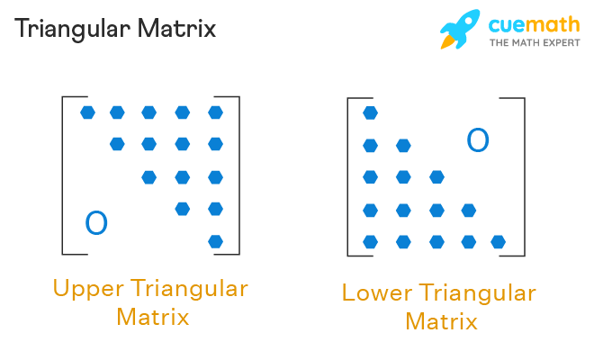

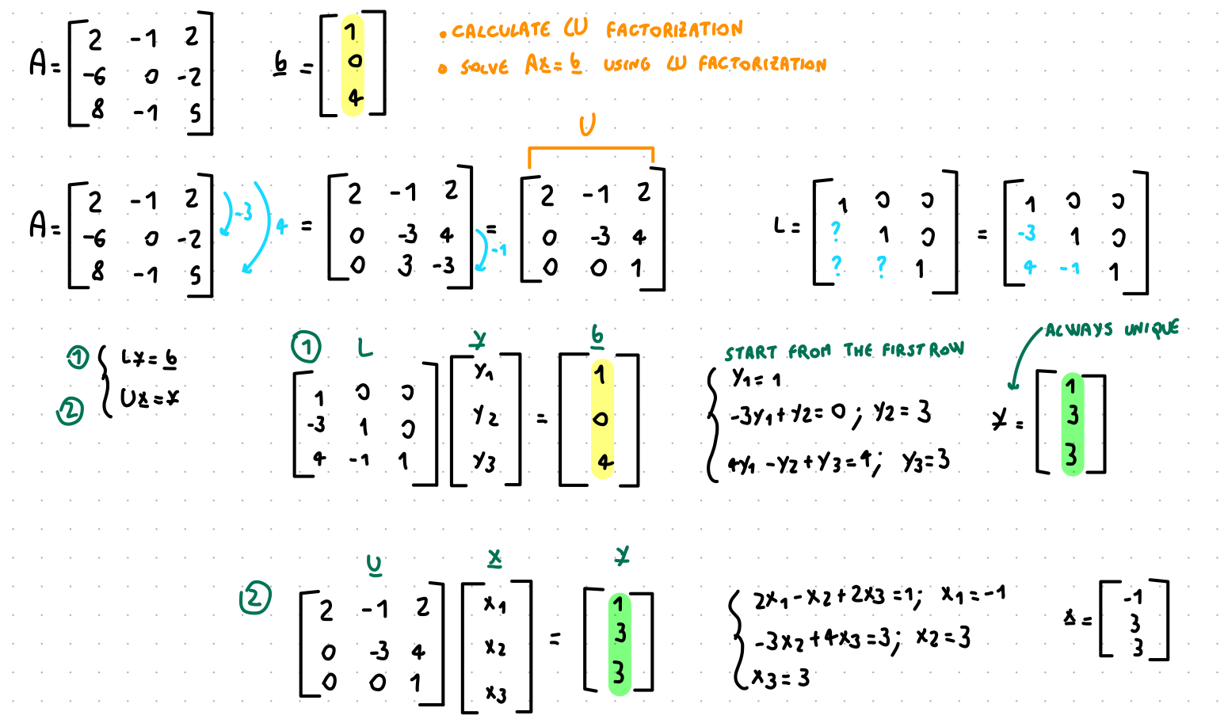

## 8.1 Lower Triangular

A matrix L is lower triangular if all entries in position (i,j) are zero for j > i

Things to know:

* The product of lower triangular matrices is a lower triangular matrix. The inverse of a lower triangular matrix (if it exists) is a lower triangular matrix

## 8.2 Upper triangular

A matrix U is upper triangular if all entries in position (i,j) are zero for i > j

Things to know:

* All echelon form matrices are upper triangular
* The product of upper triangular matrices is an upper triangular matrix. The inverse of an upper triangular matrix (if it exists) is a lower triangular matrix

# 9. Given a matrix A, find if a given vector is in Col(A), Nul(A)

Given a matrix A, a vector v ∊ Col(A) if, putting it in the matrix as the set of solutions, the matrix in E.F. has at least a solution.

For example:

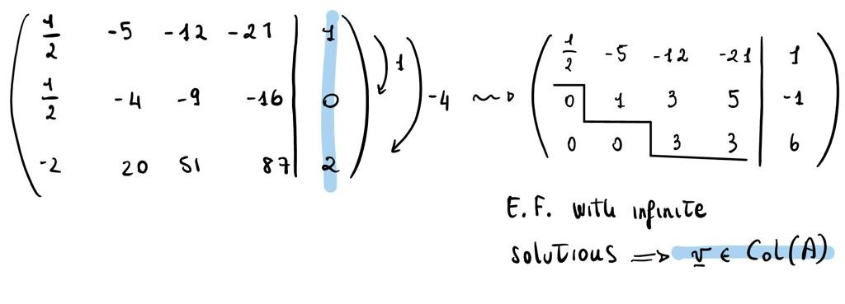

! Here, v doesn’t belong to Nul(A) sinc it belongs to R3 and A ∊ R4

Given a matrix A, a vector v ∈ Nul(A) if, doing the product between A and v the result is the zero vector.

For example:

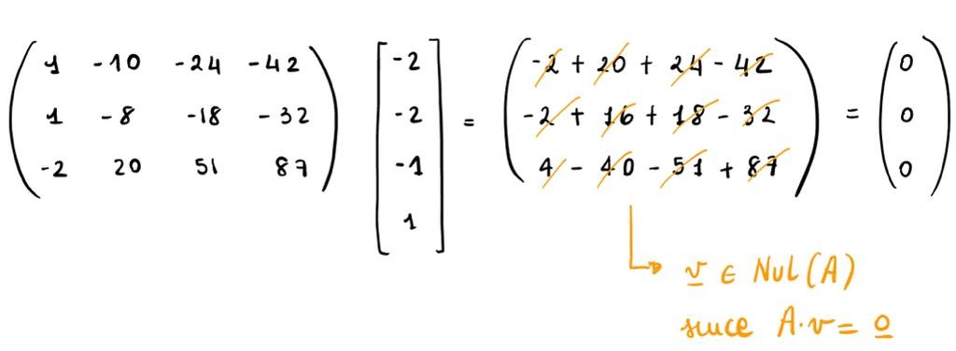

! Here v doesn’t belong to Col(A) since it belongs to R^4 and in such space the vectors belong to R^3

# 10. Given a matrix A, find a basis for Col(A), Nul(A)

A basis for Col(A) corresponds to the vectors for every column with a pivot position

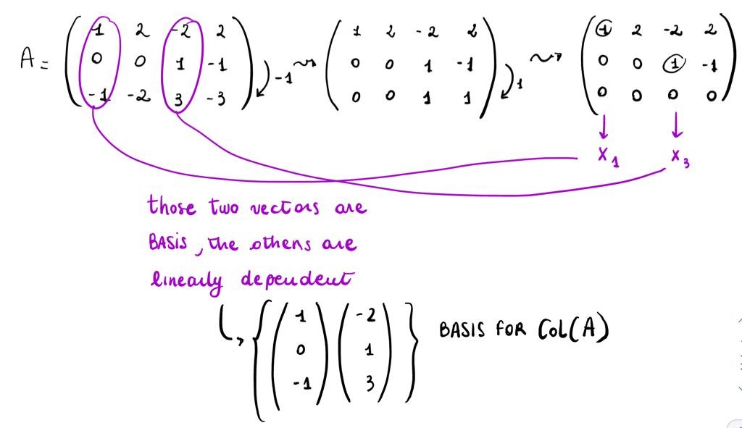

For every free variable, we find a corresponding vector in the parametric vector form of Ax=0. Therefore, you have as many vectors as the number of free variables, which corresponds to the columns without a pivot position, such vectors are a basis for Nul(A)

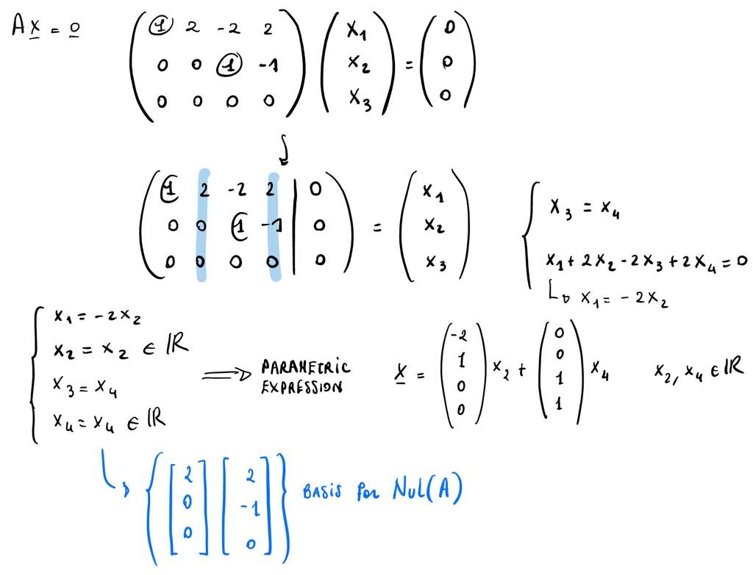

# 11. Given a set of vectors, declare if they are a basis and if a given vector is in the span

Let H be a linear subspace in Rn, a set of vectors {v1, v2, ..., vp} are a basis for H if:

* H = span{v1, v2, ..., vp}
* {v1, v2, ..., vp} are linearly independent

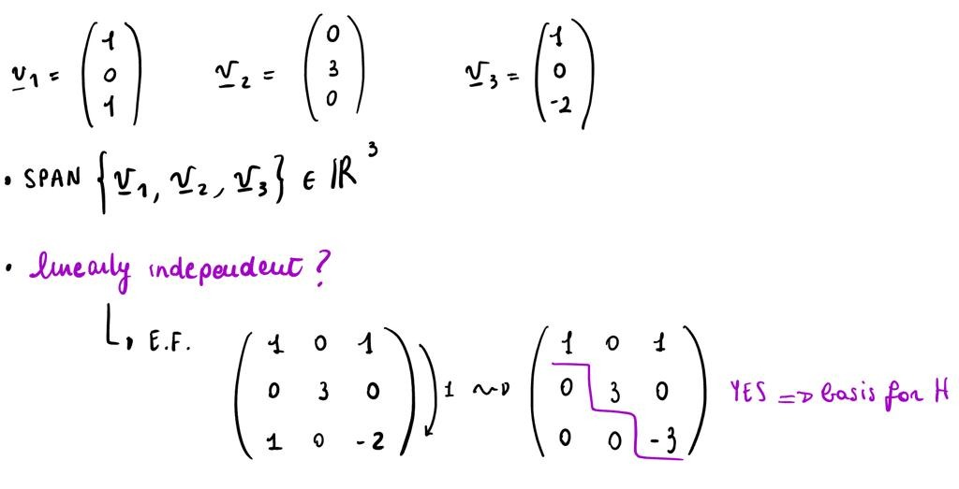

# 12. Given a basis and a vector w, write the coordinates of w with respect to that basis

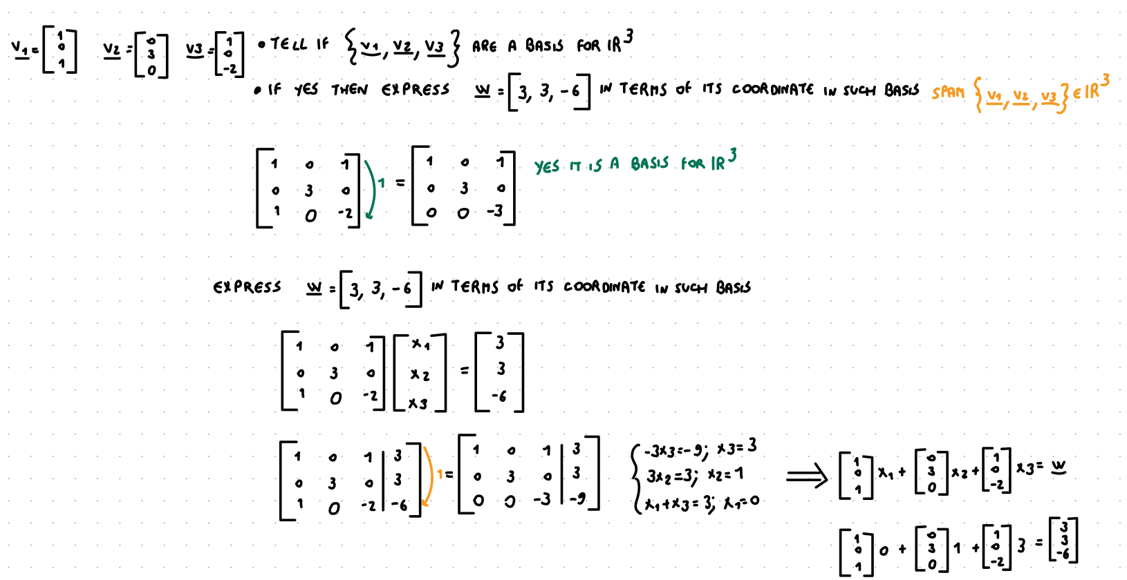

# 13. Calculate the rank of a given matrix

The rank of a matrix A € IRm x n is rank(A) = DimCol(A)

# 14. Calculate the determinant of a given square matrix using the standard formula

## 14.1 Determinant of a 2x2 square matrix

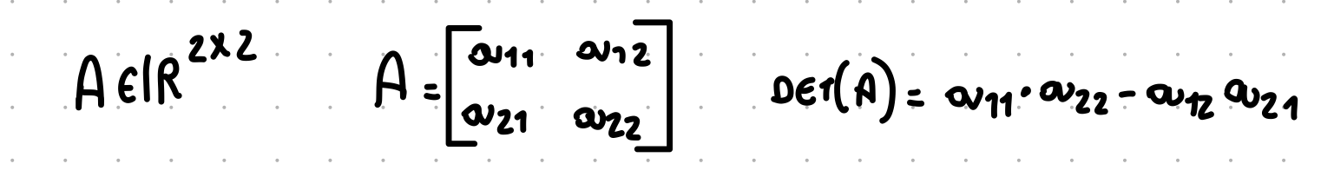

## 14.2 Determine of a 3x3 square matrix

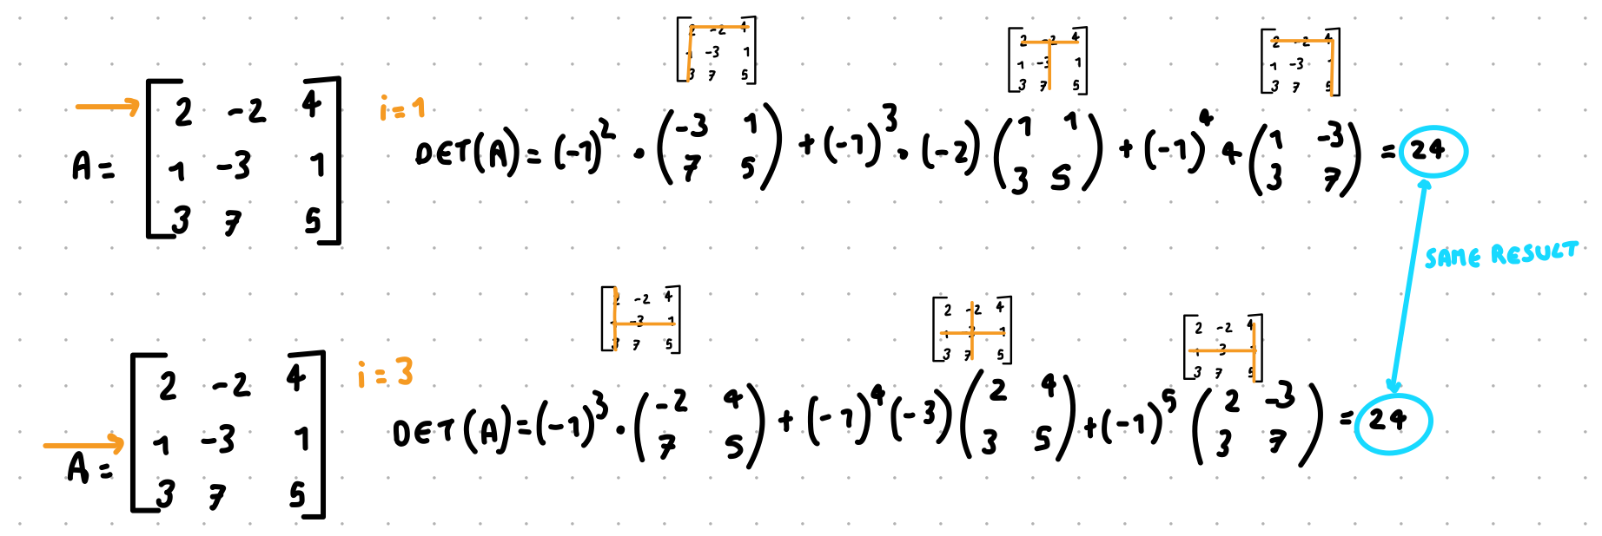

Things to know:

* If we exchange two rows of A then the determinant is multiplied by (-1)
* If we multiply a row by any α (also α = 0) then det(A) is also multiply by α
* If we subtract a multiple of a row to another row the determinant does not change

If A is transformed in a echelon form U by using “row multiplication and subtraction” and “row switching” then det(A) = “product of the diagonal terms of U times (-1)r” where r is the number of row switched

## 

# 15. Calculate the determinant of a given square matrix using the LU approach

Not sure

You know that, given a matrix A, A=LU. Hence:

* compute E.F. and find in this way U
* find L: from identity replace every * with the multipliers used for reach the E.F.

Now that we have L and U, we know that

det(A)= det(LU) = det(L) det(U) which is the Binet theorem

Example:

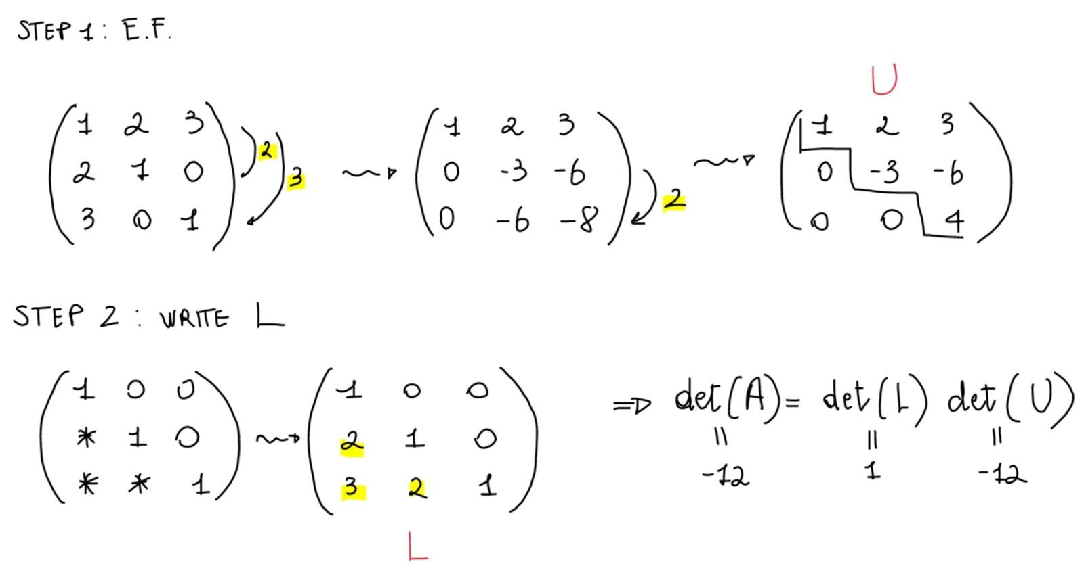

# 16. Find the (real) eigenvalues of a matrix

A € IRnxn λ € IR is λ an eigenvalue of A?

Yes iff ∃ λ € IRn such that Ax = λ xu

Iff Ax - λ x = 0 has a solution x € IRn, x ≠ 0

Iff (A - λI) x = 0 has a solution x € IRn, x ≠ 0

Therefore, what I need to check is if the homogeneous equation (A - λ I ) x = 0 has nontrivial solution ( x € IRn, x ≠ 0 )

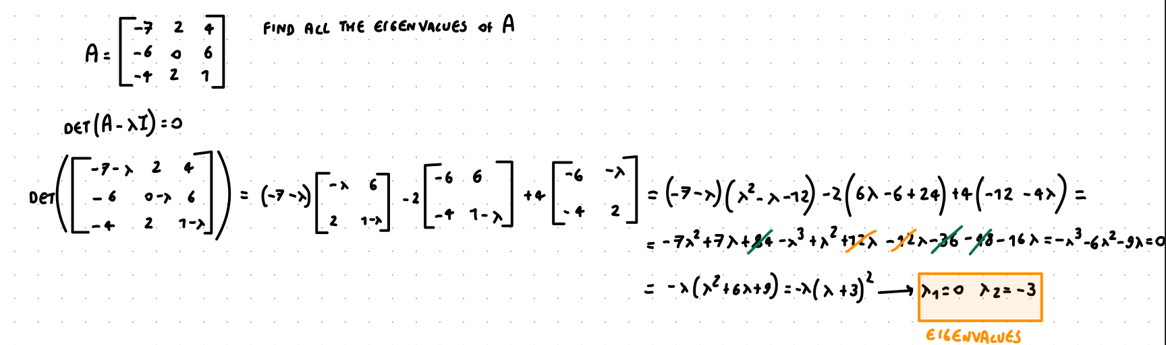

# 17. Given an eigenvalue of a matrix, calculate a basis of the associated eigenspace

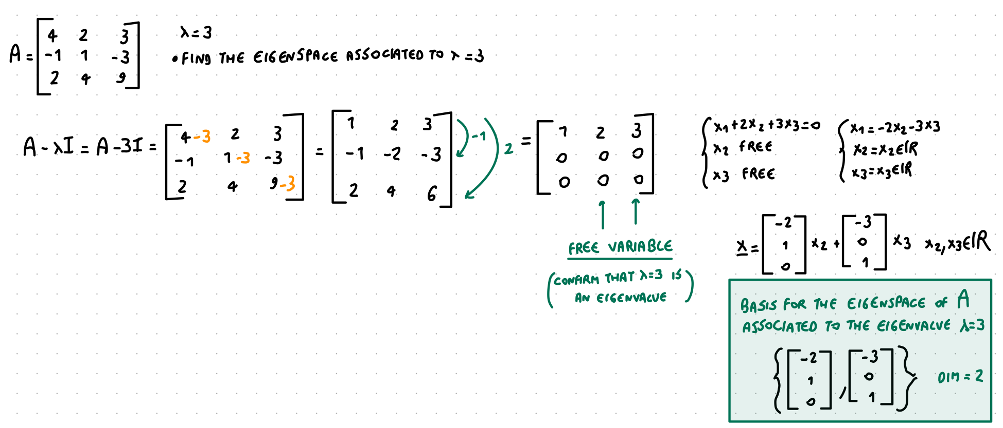

# 18. Combine the two above (find all the eigenvalues and associated eigenspaces of a matrix)

# 

# 19. Tell if a matrix is diagonalizable, and (if yes) compute the P and D matrixes

A matrix is diagonalizable if and only if I can find {v1, v2} eigenvectors and linearly independent

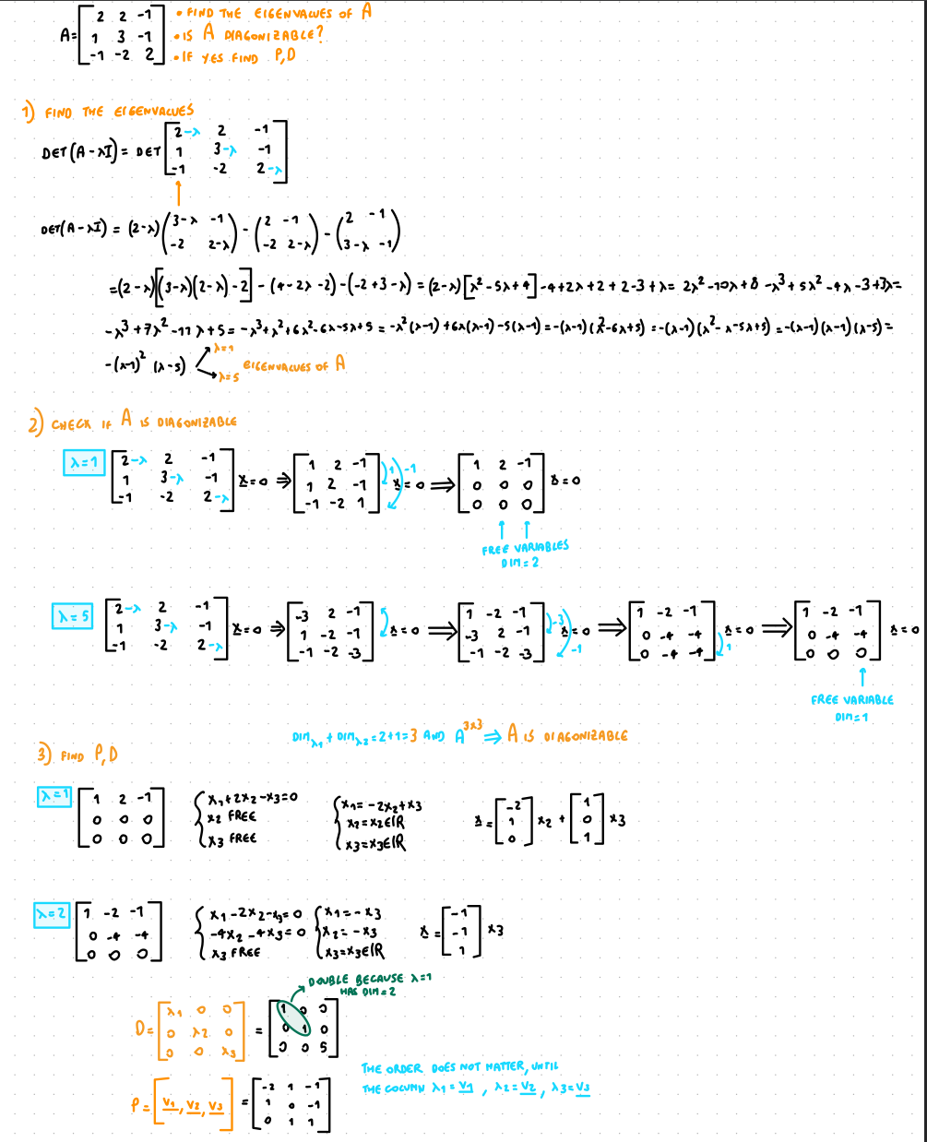

# !!! 20. Compute scalar products of vectors, norms, orthogonal projections

# 21. Given a set of linearly independent vectors spanning H, compute an orthonormal basis for H (by using the Gram-Schmidt procedure)

1. compose your matrix A as a combination of the given vectors

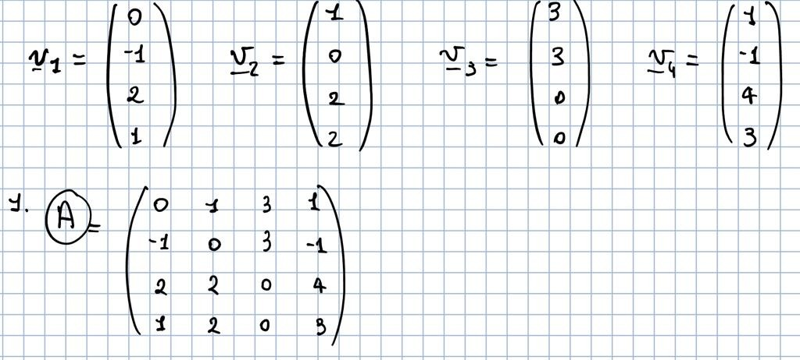

1. bring A to E.F.
2. Look at the pivot position for establishing the dimension of H

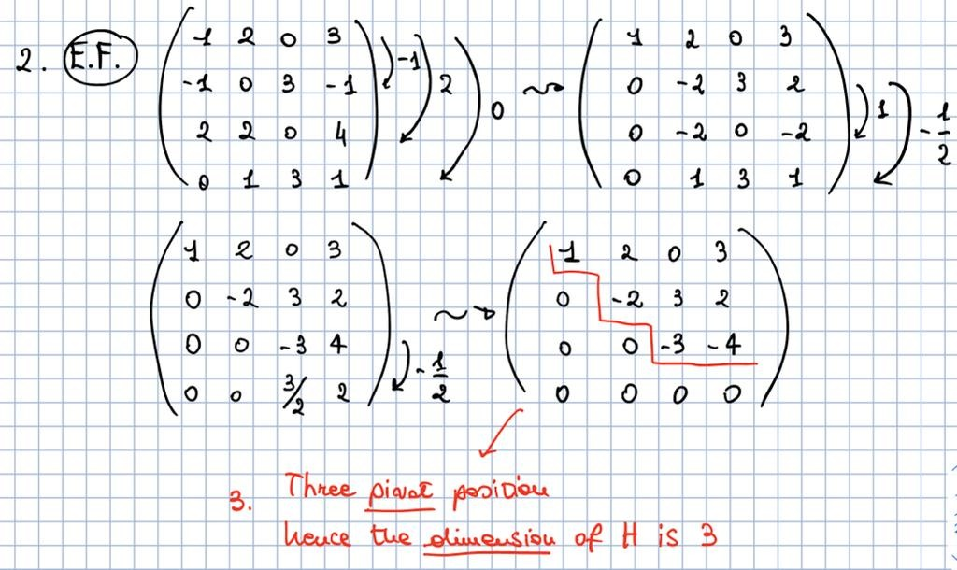

1. compute your w-vector: v1=w1

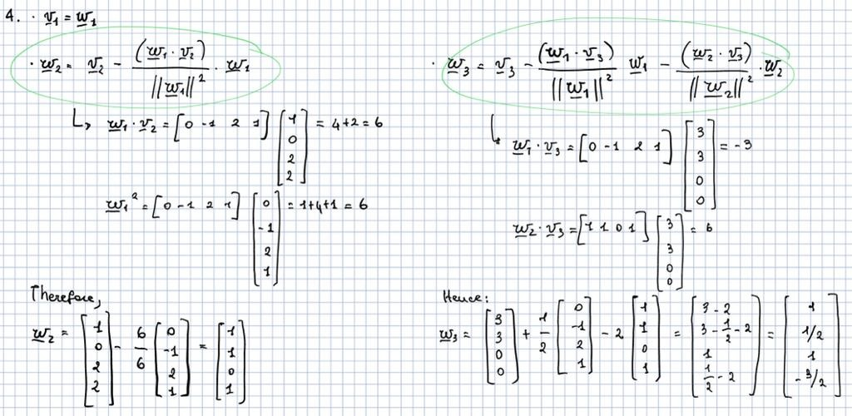

1. compose orthonormal basis= vector/its norm

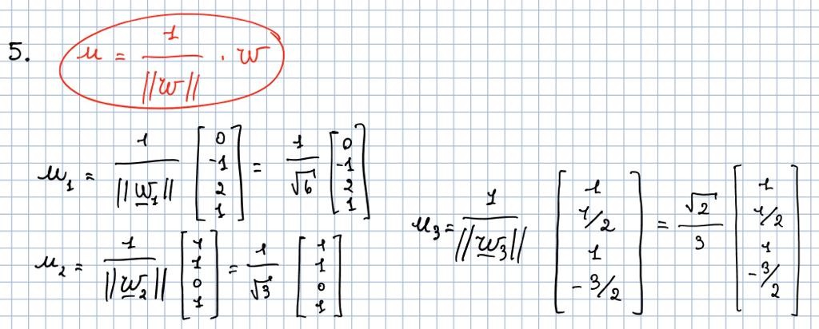

# 22. Given a matrix A with linearly independent columns, compute its QR factorization

How to compute A=QR

A=QR → QT=QT Q R ⟹ **QT A = R**

where Q is an orthonormal matrix and its columns constitute an orthonormal set spanning Col(A) and R is an upper triangular matrix with strictly positive entries in the diagonal.

Example:

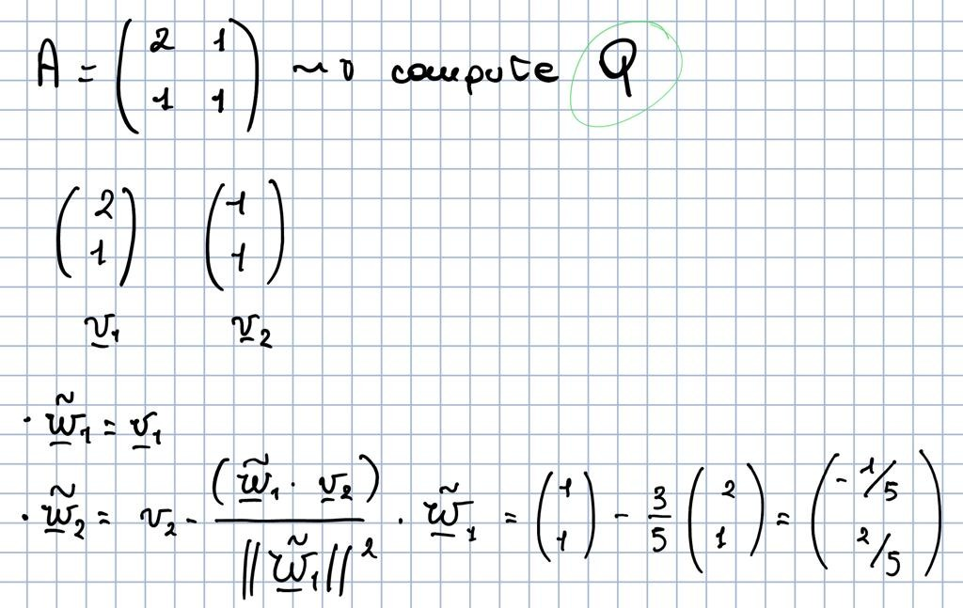

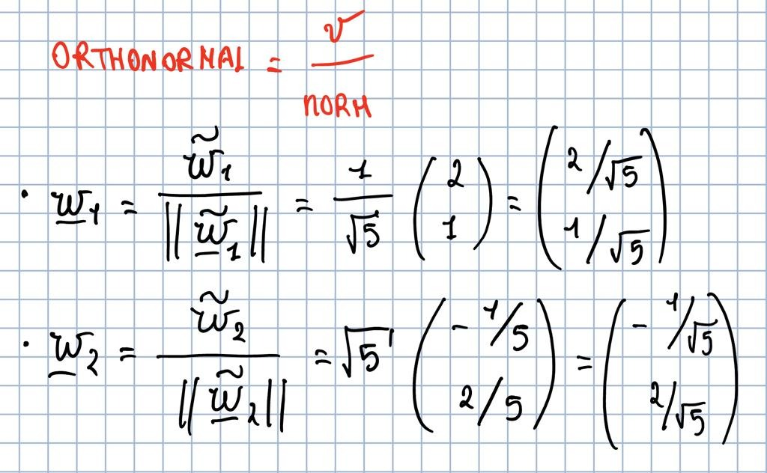

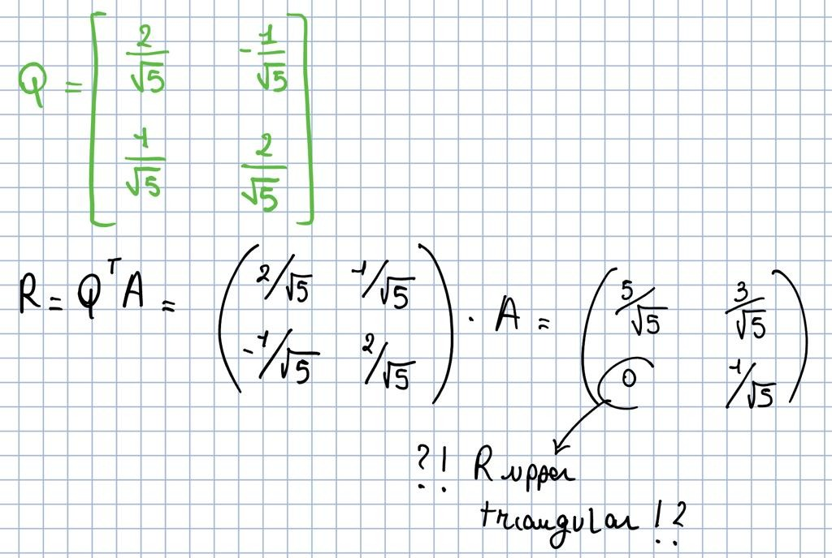

# 23. Find the solution of a least squares problem using the normal equations

The normal equation is AT A x = AT b

Given a matrix A and a b vector, you have to:

1. E.F. with b as set of solutions in your matrix

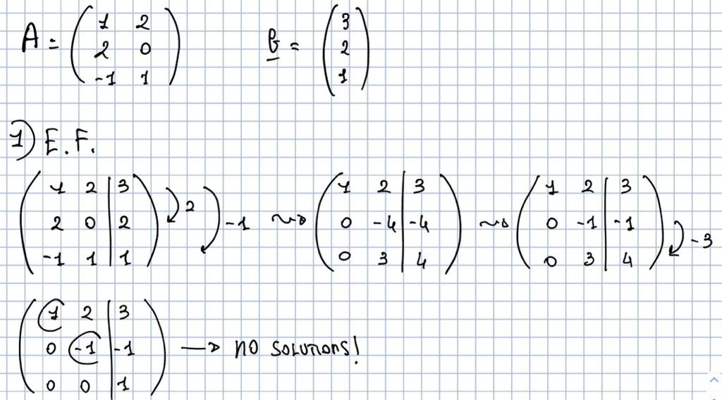

1. compute AT A

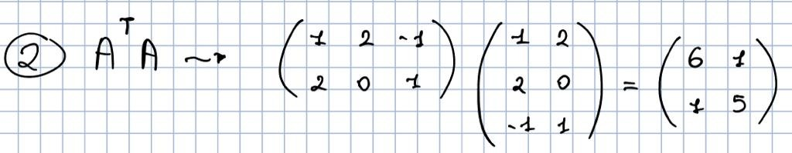

1. compute AT b

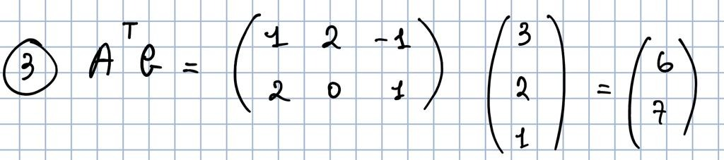

1. compose the normal equation AT A x = AT b
2. finally porcodio one can find x

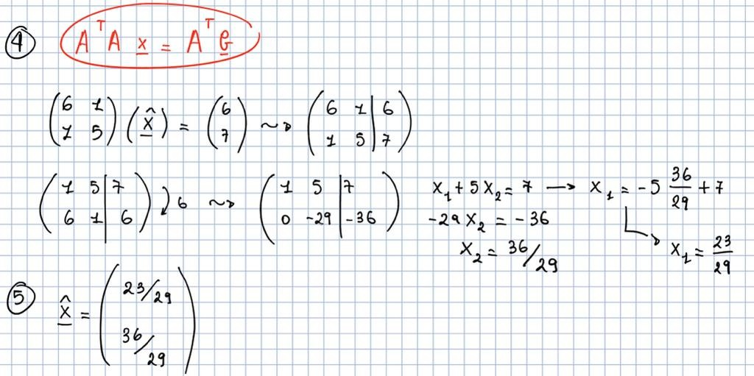

Example for clarification che sennó non si capisce nulla

# 24. Find the solution of a least squares problem using the QR factorization

Given a matrix A and a vector b:

1. compute all the w-vectors and their orthonormal vector
2. compose Q
3. find R from eq. R=Q^T A
4. build the linear system Rx = Q^T b

ex messaggio tito

# 25. Given a matrix A, answer if the associated least squares problem has a unique solution

Remarking that for Th. n. 18 the following statements are equivalent:

1. the least square problem has a unique solution A^T A x = A^T b
2. AT A is invertible
3. the columns of A are linear independent

Using these statements one can demonstrate that the associated least squares problem has a unique solution:

yho sbagliato dei calcoli lol ma il concetto e quello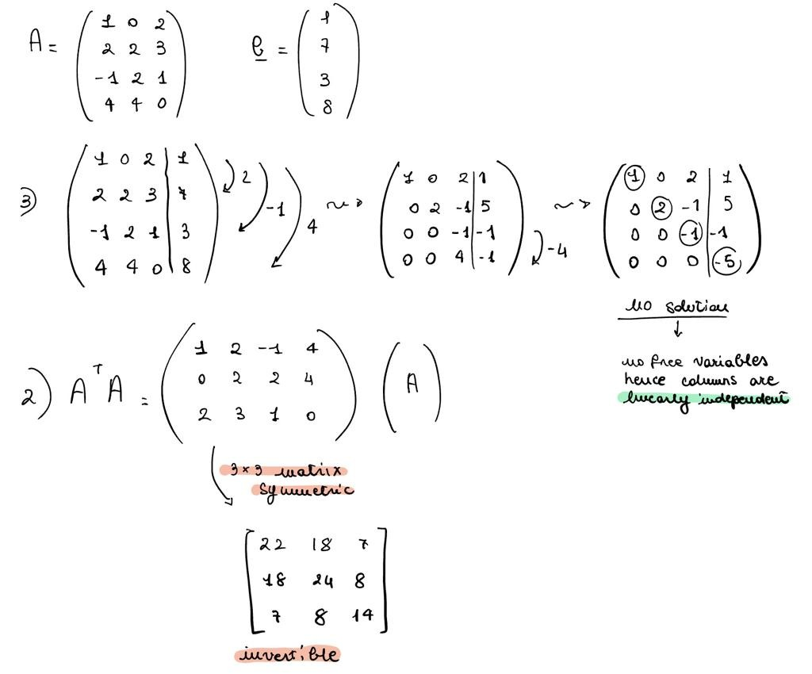

1. Solve a linear system

Use elementary row operations

1. Exchange two rows
2. Multiply any row by α € IR, α ≠ 0
3. Subtract and row multiply by α € IR to any other row



1.2 Understand the possible solutions



2. Write a matrix in EF (Echelon Form)

Use the elementary row operation to have a matrix in the form:



- All rows full of zeros ar at the bottom

- The leading entry (leftmost non-zero entry) is on the right of the leading entry of the rows above

* general number

0 zero

* different from zero

Things to know:

* Any matrix can be transformed in echelon form (EF) by the row reduction algorithm (sequence of elementary row operation)
* Any matrix is row equivalent to a matrix in EF, such EF matrix is not unique
* Even if there are multiple EF matrix for the same matrix, the position of the leading entry of all the rows of the EF matrixes are the same



3. Write a matrix in REF (Reduced Echelon Form)

Given a matrix in the Echelon Form, if it also satisfies the following properties:

1. The leading entry of each non-zero row is 1
2. Each leading 1 is the only non zero entry of its column

Then the matrix is in REF

Things to know:

* The EF (Echelon Form) is not unique
* The REF (Reduced Echelon Form) is unique
* All the REF are also in EF, but not all the EF are also in REF

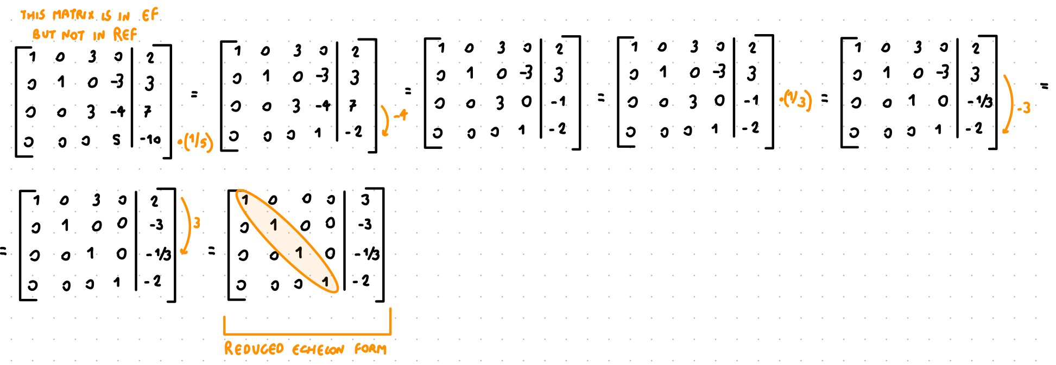

3.2 REF algorithm

1. Begin with the rightmost pivot
2. If the pivot = 1 is ok, otherwise divide the row by the pivot itself
3. Create 0 over the pivot by row replacement

4. Product of a matrix and a vector



5. Search satisfiability

Given A € IRm x n and b € IRm search for x € IRn that satisfy Ax = b

Things to know:

* The linear system will have at least (or one or infinite) solutions of x



6. Homogeneous linear system

* A system of linear equation is homogeneous if it can be written as Ax = 0
* An homogeneous linear system has always the trivial solution (vector 0)
* An homogeneous linear system has a non-trivial solution if there is at least one free variable



7. Check if a set of vectors is linearly independent or linearly dependent

Linearly independent: only one solution (all 0)

Linearly dependent: there exists at least one solution that is ≠ 0



Things to know:

* Free variable ⟹ infinite solutions ⟹ linearly dependent
* No free variable ⟹ one solution (0 vector) ⟹ linearly independent
* Given {v1, v2, v3, … , vp } € IRn if **p > n** they must be linearly dependent
* Given {v1, v2, v3, … , vp } € IRn if one of the vector is equal to 0 the vectors are linearly dependent

8. Product of matrix

First of all test if you can multiply two matrices

if A € IRn x m and B € IRo x p you can do AB only if *m=o* that is only if the number of columns of the first matrix is the same as the number of rows of the second matrix. Furthermore the result matrix will be a matrix € IRn x p

AB ≠ BA



Things to know:

* AB ≠ BA
* If AB = AC ⇏ B = C
* If AB =0 (0 is a matrix) ⇏ A=0 or B=0
* A0 = In (only for square matrixes)

9. Transpose of a matrix (AT)

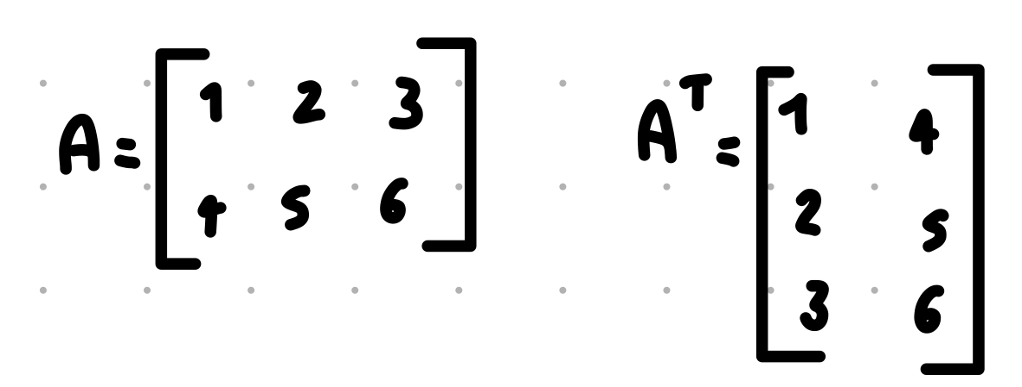

Things to know:

* The diagonal does not change

10. Invertibile Matrix

Given a square matrix A € IRn x n is invertible if it exist C € IRn x n such that CA = AC = In otherwise A is said non-invertibile



Things to know:

* A matrix to be invertible needs to be **squared** and needs to have a **pivot position for all the rows**
* If C exist it is unique and is the inverse of A, usually indicated with A-1

A € IRn x n (square) than the following statements are equivalent

* A is invertibile
* A is row-equivalent to In
* A has n pivot positions (all on the diagonal)
* The system Ax = 0 has only the trivial solution
* The equation Ax = b has (at least) one solution for each b€ IRn
* The columns of A span all IRn
* There is C € IRn x n such that CA = In
* There is C € IRn x n such that AC = In
* At is an invertible matrix

11. Lower and Upper Triangular



11.1 Lower Triangular

A matrix L is lower triangular if all entries in position (i,j) are zero for j > i

Things to know:

* The product of lower triangular matrices is a lower triangular matrix. The inverse of a lower triangular matrix (if it exists) is a lower triangular matrix

11.2 Upper triangular

A matrix U is upper triangular if all entries in position (i,j) are zero for i > j

Things to know:

* All echelon form matrices are upper triangular
* The product of upper triangular matrices is an upper triangular matrix. The inverse of an upper triangular matrix (if it exists) is a lower triangular matrix

12. LU factorization

A = LU

(A: matrix, L: lower triangular matrix of A, U: upper triangular matrix of A)

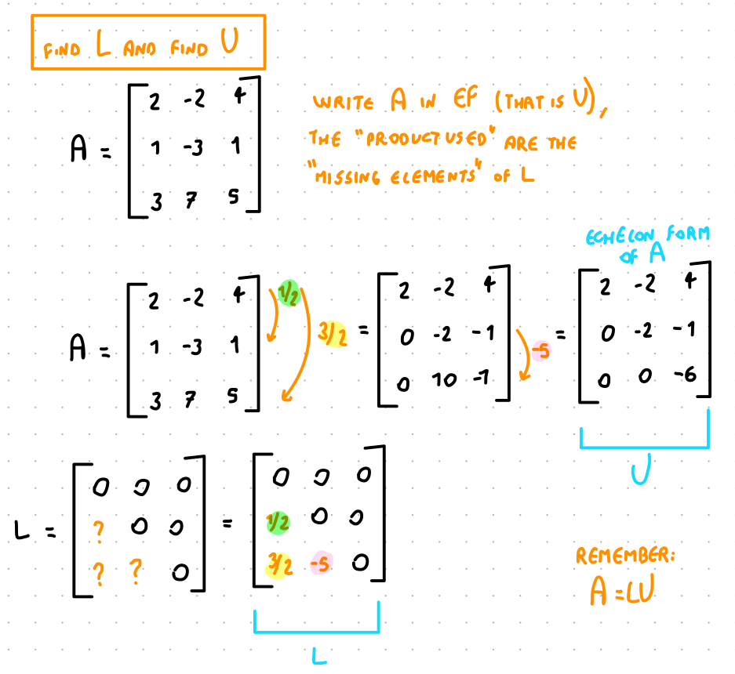

Things to know:

* If you have some missing information of L (not all the steps might be necessary to do EF) then put a 0 in the corresponding place

12.1 LU factorization and solving Ax = b



13. Subspace of IRn

Given a Matrix A ⊆ IRm x n

IRn

IRn

14. Tell if a set of vectors is a basis for IRn

lez 7

15. Find if a set of vector are a basis

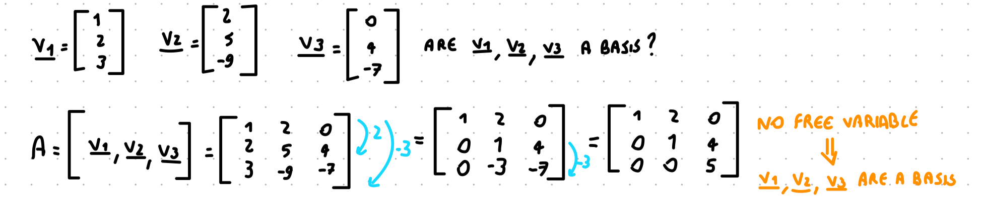

16. Find the coordinates of a vector wrt others vectors

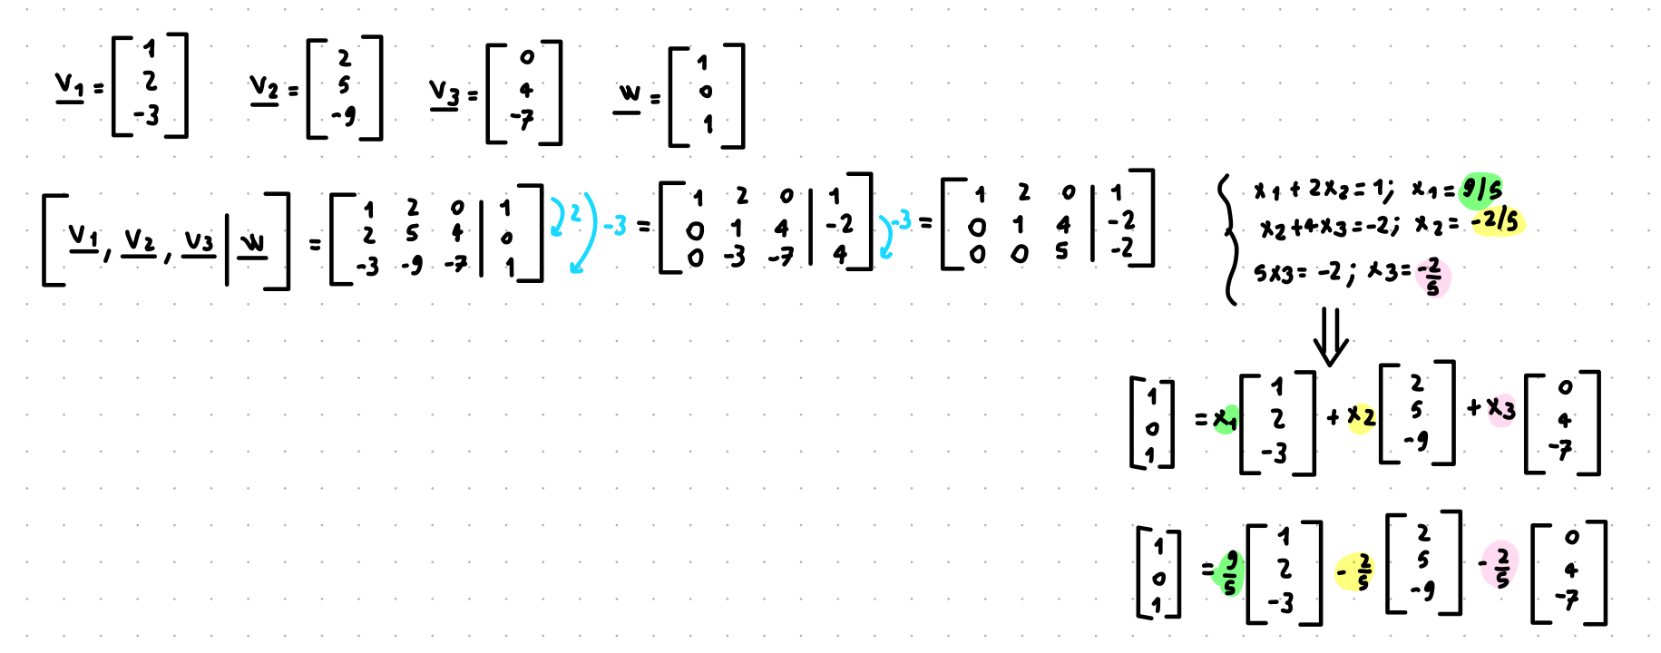

17. Determinant

Things to know:

* The determinant tell if a square matrix is invertible
* If A is a square matrix and det(A) ≠ 0 then A is invertible

17.1 Determinant for 2x2 matrix

